Name______________________________ Date_________________________
Geometry
Circles and Chords

Perpendicular Chord Bisector Theorem

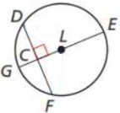
Example 1:
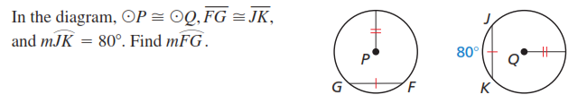

Example 2:
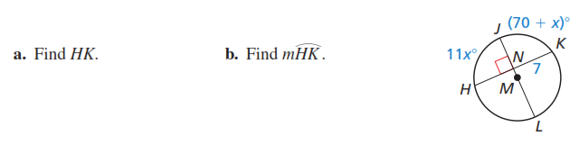

Example 3:
In circle M, $\overline{JL}⊥\overline{HK}$; $\overline{NK}=6,$and $\overline{NL}=8$. Find the length of $\overline{HL}$.
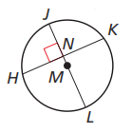
Equidistant Chords Theorem

Example 4:
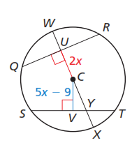

Example 5:
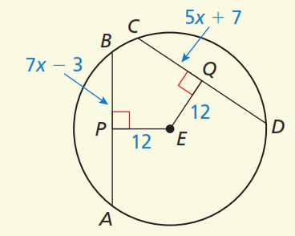
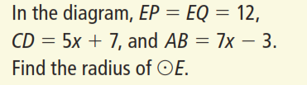

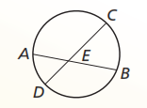
Segments of Chords Theorem

Theorem: Given circle with intersecting chords AB and CD, then

Example 6: Example 7:
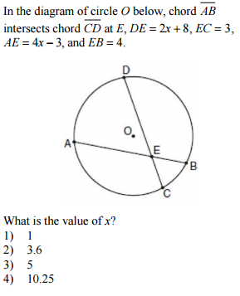
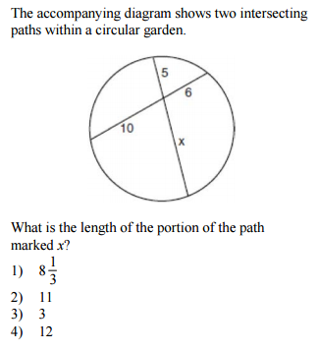

Example 8:

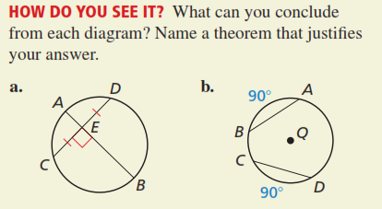

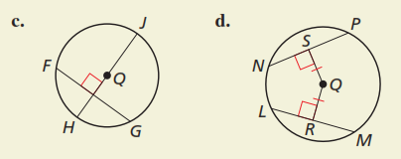

Example 9:
